**Develop a linear regression model for forecasting time series data.**

**AIM:**

**TO Develop a linear regression model for forecasting time series data.**

**PROCEDURE:**

import numpy as np

import pandas as pd

from sklearn.linear_model import LinearRegression

from sklearn.

model_selection import train_test_split

from sklearn.metrics import mean_absolute_error, mean_squared_error

import matplotlib.pyplot as plt

# 1. Prepare Data

# Load your time series data (example: sales data with a timestamp column)

# Assuming your data has 'timestamp' and 'target' columns

# Example: creating a sample dataset (you can replace this with actual data)

date_rng = pd.date_range(start='1/1/2020', end='12/31/2020', freq='D')

data = pd.DataFrame(date_rng, columns=['timestamp'])

data['target'] = np.random.rand(len(data)) * 100 # Random target data (replace with actual data)

# 2. Feature Engineering

# We can use the date itself (e.g., day of the year) as a feature.

data['day_of_year'] = data['timestamp'].dt.dayofyear

# 3. Train-Test Split (chronological split, NOT random)

train = data[:int(0.8 * len(data))] # 80% training data

test = data[int(0.8 * len(data)):] # 20% testing data

# 4. Define Features (X) and Target (y)

X_train = train[['day_of_year']] # Feature (independent variable)

y_train = train['target'] # Target (dependent variable)

X_test = test[['day_of_year']]

y_test = test['target']

# 5. Train Linear Regression Model

model = LinearRegression()

model.fit(X_train, y_train)

# 6. Make Predictions

y_pred = model.predict(X_test)

# 7. Evaluate the Model

mae = mean_absolute_error(y_test, y_pred)

rmse = np.sqrt(mean_squared_error(y_test, y_pred))

print(f'Mean Absolute Error (MAE): {mae}')

print(f'Root Mean Squared Error (RMSE): {rmse}')

# Plot the actual vs predicted values

plt.figure(figsize=(10, 6))

plt.plot(test['timestamp'], y_test, label='Actual')

plt.plot(test['timestamp'], y_pred, label='Predicted', linestyle='--')

plt.legend()

plt.title('Time Series Forecasting with Linear Regression')

plt.xlabel('Date')

plt.ylabel('Target')

plt.show()

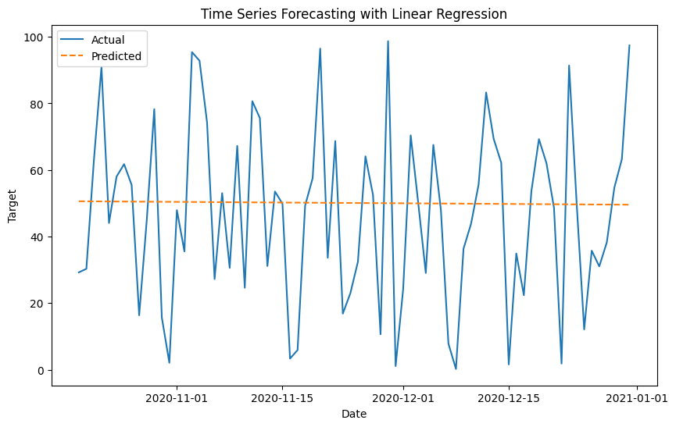

**RESULT:**

Thus the program has been excecuted successfully.